**Task 1**

1. How to write your first React component

Tasks:

1. Create a simple functional component named Greeting that returns “Hello,

World!” within a <h1> tag.

**Greeting.jsx**

import React from 'react'

export default function Greeting() {

return (

<>

<h1>Hello World!</h1>

</>

)

}

**Main.jsx**

import { StrictMode } from 'react'

import { createRoot } from 'react-dom/client'

import './index.css'

import App from './App.jsx'

import Greeting from './Greeting.jsx'

createRoot(document.getElementById('root')).render(

<StrictMode>

<Greeting />

</StrictMode>,

)

**Output**

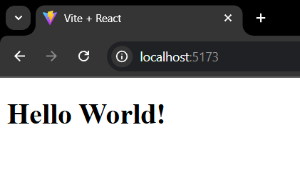

2. Modify the Greeting component to display “Hello, React!”.

**Greeting.jsx**

import React from 'react'

export default function Greeting() {

return (

<>

<h1>Hello, React!</h1>

</>

)

}

**Main.jsx**

import { StrictMode } from 'react'

import { createRoot } from 'react-dom/client'

import './index.css'

import App from './App.jsx'

import Greeting from './Greeting.jsx'

createRoot(document.getElementById('root')).render(

<StrictMode>

<Greeting />

</StrictMode>,

)

**Output**

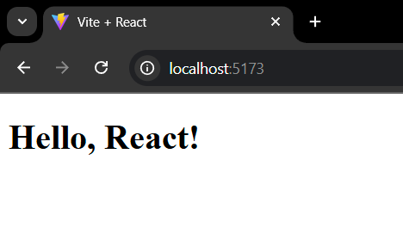

3. Create a Gallery functional component to display an image.

**Gallery.jsx**

import React from 'react'

export default function Gallery() {

return (

<>

<img src='https://encrypted-tbn0.gstatic.com/images?q=tbn:ANd9GcRFU7U2h0umyF0P6E_yhTX45sGgPEQAbGaJ4g&s'></img>

</>

)

}

**Main.jsx**

import { StrictMode } from 'react'

import { createRoot } from 'react-dom/client'

import './index.css'

import App from './App.jsx'

import Greeting from './Greeting.jsx'

import Gallery from './Gallery.jsx'

createRoot(document.getElementById('root')).render(

<StrictMode>

<Gallery />

</StrictMode>,

)

**Output**

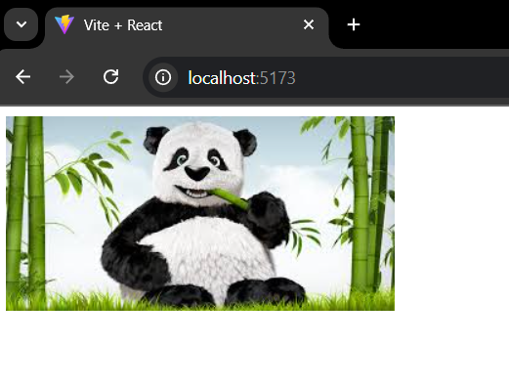

4. Add Greeting to the Gallery component and display the image and greeting.

**Gallery.jsx**

import React from 'react'

import Greeting from './Greeting'

export default function Gallery() {

return (

<>

<Greeting />

<img src='https://encrypted-tbn0.gstatic.com/images?q=tbn:ANd9GcRFU7U2h0umyF0P6E_yhTX45sGgPEQAbGaJ4g&s'></img>

</>

)

}

**Greeting.jsx**

import React from 'react'

export default function Greeting() {

return (

<>

<h1>Hello, React!</h1>

</>

)

}

**Main.jsx**

import { StrictMode } from 'react'

import { createRoot } from 'react-dom/client'

import './index.css'

import App from './App.jsx'

import Greeting from './Greeting.jsx'

import Gallery from './Gallery.jsx'

createRoot(document.getElementById('root')).render(

<StrictMode>

<Gallery />

</StrictMode>,

)

**Output**

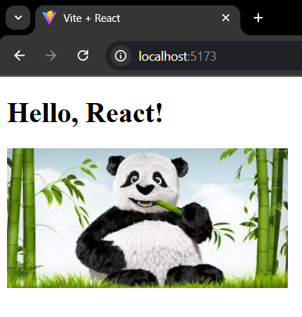

5. Write a component called Profile which displays a hardcoded user’s name and

age.

**Profile.jsx**

import React from 'react'

export default function Profile() {

const name='kavin'

const age=21

return (

<>

<h1>{name}</h1>

<h1>{age}</h1>

</>

)

}

**Main.jsx**

import { StrictMode } from 'react'

import { createRoot } from 'react-dom/client'

import './index.css'

import App from './App.jsx'

import Greeting from './Greeting.jsx'

import Gallery from './Gallery.jsx'

import Profile from './Profile.jsx'

createRoot(document.getElementById('root')).render(

<StrictMode>

<Profile />

</StrictMode>,

)

**Output**

